# Name: Amna Muqeem

# Class: BSCS 7B

# CMS: 216259

# AP LAB 6 - MongoDB

### No specific data was provided in the first few tasks thus I made my own documents to insert them into the customers collection. Therefore I do not have the similar “name” and “address” fields as in w3schools.

## Task 1:

var MongoClient = require('mongodb').MongoClient;

var url = "mongodb://localhost:27017/mydb";

MongoClient.connect(url, function(err, db) {

if (err) throw err;

console.log("Database created!");

db.close();

});

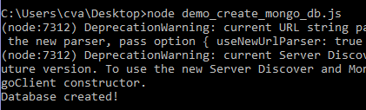

## Task 2:

var MongoClient = require('mongodb').MongoClient;

var url = "mongodb://localhost:27017/";

MongoClient.connect(url, function(err, db) {

if (err) throw err;

var dbo = db.db("mydb");

dbo.createCollection("customers", function(err, res){

if (err) throw err;

console.log("Customers collection created!");

db.close();

}); });

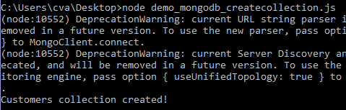

## Task 3:

var MongoClient = require('mongodb').MongoClient;

var url = "mongodb://localhost:27017/";

MongoClient.connect(url, { useUnifiedTopology: true }, { useNewUrlParser: true }, function(err, db) {

if (err) throw err;

var dbo = db.db("mydb");

var doc = { name: "Amna", Age: 20 };

dbo.collection("customers").insertOne( doc, function(err, res){

if (err) throw err;

console.log("Document Inserted!");

db.close();

}); });

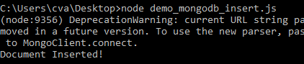

## **Task 4:**

var MongoClient = require('mongodb').MongoClient;

var url = "mongodb://localhost:27017/";

MongoClient.connect(url, { useUnifiedTopology: true }, { useNewUrlParser: true }, function(err, db) {

if (err) throw err;

var dbo = db.db("mydb");

var doc = [ { name: "Amna", Age: 20 }, { name: "Immad", Age: 21 }, { name: "Ayesha", Age: 19 }, { name: "Aksa", Age: 20 } ];

dbo.collection("customers").insertMany( doc, function(err, res){

if (err) throw err;

console.log("Documents Inserted!");

db.close();

}); });

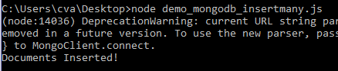

## Task 5:

var MongoClient = require('mongodb').MongoClient;

var url = "mongodb://localhost:27017/";

MongoClient.connect(url, { useUnifiedTopology: true }, { useNewUrlParser: true }, function(err, db) {

if (err) throw err;

var dbo = db.db("mydb");

var doc = [ { _id: 1, name: "jam" }, { _id: 2, name: "beans" }, { _id: 3, name: "butter" } ];

dbo.collection("products").insertMany( doc, function(err, res){

if (err) throw err;

console.log("3 products inserted!");

console.log(res);

db.close();

}); });

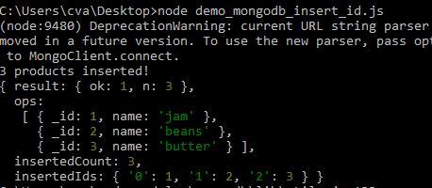

## Task 6:

var MongoClient = require('mongodb').MongoClient;

var url = "mongodb://localhost:27017/";

MongoClient.connect(url, { useUnifiedTopology: true }, { useNewUrlParser: true }, function(err, db) {

if (err) throw err;

var dbo = db.db("mydb");

dbo.collection("customers").findOne( {}, function(err, res){

if (err) throw err;

console.log(res);

db.close();

}); });

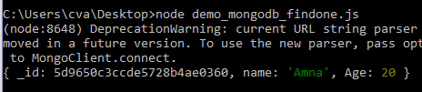

## Task 7:

var MongoClient = require('mongodb').MongoClient;

var url = "mongodb://localhost:27017/";

MongoClient.connect(url, { useUnifiedTopology: true }, { useNewUrlParser: true }, function(err, db) {

if (err) throw err;

var dbo = db.db("mydb");

dbo.collection("customers").find( {}, { projection : {_id: 0, name: 1, age: 1} }).toArray( function(err, res){

if (err) throw err;

console.log(res);

db.close();

}); });

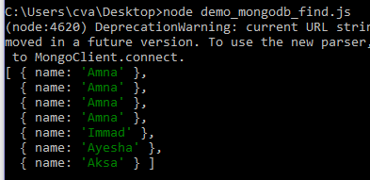

## Task 8:

var MongoClient = require('mongodb').MongoClient;

var url = "mongodb://localhost:27017/";

MongoClient.connect(url, { useUnifiedTopology: true }, { useNewUrlParser: true }, function(err, db) {

if (err) throw err;

var dbo = db.db("mydb");

var query = { name: "Immad" };

dbo.collection("customers").find(query).toArray( function(err, res){

if (err) throw err;

console.log(res);

db.close();

}); });

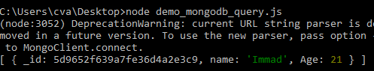

## Task 9:

var MongoClient = require('mongodb').MongoClient;

var url = "mongodb://localhost:27017/";

MongoClient.connect(url, { useUnifiedTopology: true }, { useNewUrlParser: true }, function(err, db) {

if (err) throw err;

var dbo = db.db("mydb");

var sort = { name: 1 };

dbo.collection("customers").find().sort(sort).toArray( function(err, res){

if (err) throw err;

console.log(res);

db.close();

}); });

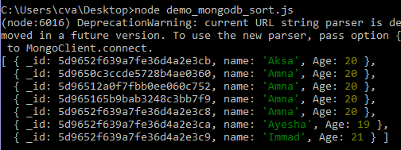

## Task 10:

var MongoClient = require('mongodb').MongoClient;

var url = "mongodb://localhost:27017/";

MongoClient.connect(url, { useUnifiedTopology: true }, { useNewUrlParser: true }, function(err, db) {

if (err) throw err;

var dbo = db.db("mydb");

var q = { name: 'Aksa' };

dbo.collection("customers").deleteOne(q, function(err, obj){

if (err) throw err;

console.log("Deleted.");

db.close();

}); });

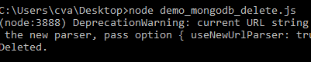

## Task 11:

var MongoClient = require('mongodb').MongoClient;

var url = "mongodb://localhost:27017/";

MongoClient.connect(url, { useUnifiedTopology: true }, { useNewUrlParser: true }, function(err, db) {

if (err) throw err;

var dbo = db.db("mydb");

var q = { name: /^A/ };

dbo.collection("customers").deleteMany(q, function(err, obj) {

if (err) throw err;

console.log(obj.result.n + " documents deleted.");

db.close();

}); });

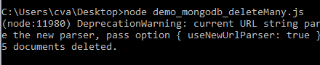

## Task 12:

var MongoClient = require('mongodb').MongoClient;

var url = "mongodb://localhost:27017/";

MongoClient.connect(url, { useUnifiedTopology: true }, { useNewUrlParser: true }, function(err, db) {

if (err) throw err;

var dbo = db.db("mydb");

dbo.collection("customers").drop(function(err, deleted) {

if (err) throw err;

if (deleted) console.log("Collection is deleted.");

db.close();

}); });

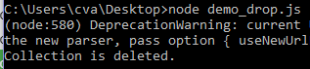

## Task 13:

var MongoClient = require('mongodb').MongoClient;

var url = "mongodb://localhost:27017/";

MongoClient.connect(url, { useUnifiedTopology: true }, { useNewUrlParser: true }, function(err, db) {

if (err) throw err;

var dbo = db.db("mydb");

var q = { name: "Immad" };

var newval = { $set: {name: "ImmadAmir", age: "22" } };

dbo.collection("customers").updateOne(q, newval, function(err, res) {

if (err) throw err;

console.log("One document updated");

db.close();

}); });

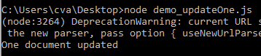

## Task 14:

var MongoClient = require('mongodb').MongoClient;

var url = "mongodb://localhost:27017/";

MongoClient.connect(url, { useUnifiedTopology: true }, { useNewUrlParser: true }, function(err, db) {

if (err) throw err;

var dbo = db.db("mydb");

dbo.collection("customers").find().limit(5).toArray(function(err, res) {

if (err) throw err;

console.log(res);

db.close();

}); });

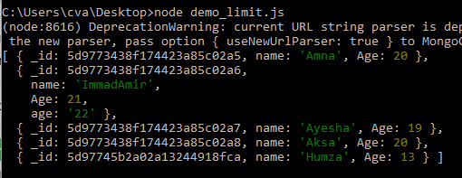

## Task 15:

var MongoClient = require('mongodb').MongoClient;

var url = "mongodb://localhost:27017/";

MongoClient.connect(url, { useUnifiedTopology: true }, { useNewUrlParser: true }, function(err, db) {

if (err) throw err;

var dbo = db.db("mydb");

dbo.collection('people').aggregate([

{ $lookup:

{

from: 'products',

localField: '_id',

foreignField: '_id',

as: 'buyers'

}

}

]).toArray(function(err, res) {

if (err) throw err;

console.log(JSON.stringify(res));

db.close();

}); });

